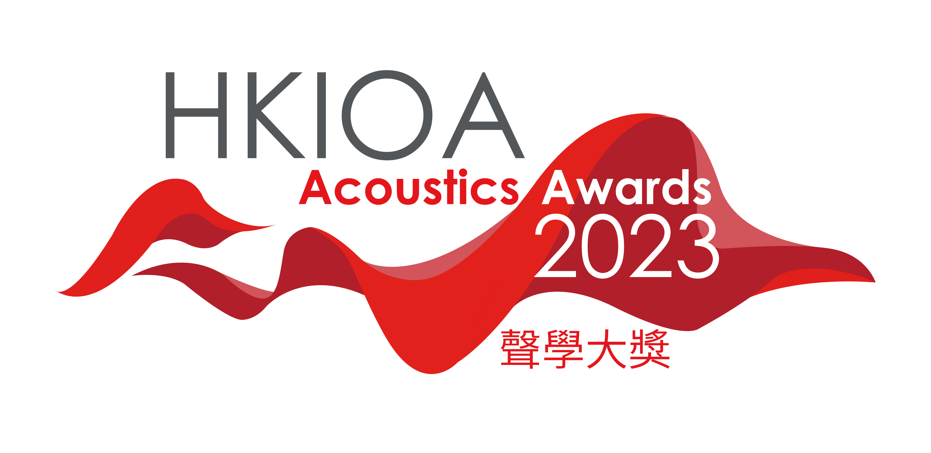
Instructions for preparing the submission of the application for HKIOA Acoustics Awards 2023

Submission Guidelines
This paper is a template to which you can refer for your application. The purpose of these instructions is to ensure the uniformity of the submission.

- The submission should be submitted in PDF file format.
- Submission should be written in English, in Times New Roman, shall not be smaller than font size 10 and larger than font size 12, in single line spacing.
- The submission length should be not more than most ten(10) pages in A4 size.
- Margin settings: Top (2.54 cm), Bottom (2.54 cm), Left (2.54 cm), Right (2.54 cm).
- The file size should not be more than 20Mbyte

Entry Title XXXXXXXX (The title should be written in "Times New Roman", 14-point, bold font. The first alphabet of the first word in the title should be capitalized)

- Concept
Xxxxxxxxxxxxxxxxxxxxxxxxxxxxxxxxxxxxxxxxxxxxxxxxxxxxxxxxxxxxxxxxxxxxxxxxxxxxxxxxxxxxxxxxxxxxxxxxxxxxxxxxxxxxxxxxxxxxxxxxxxxxxxxxxxxxxxxxxxxxxxxxxxxxxxx

- Innovation
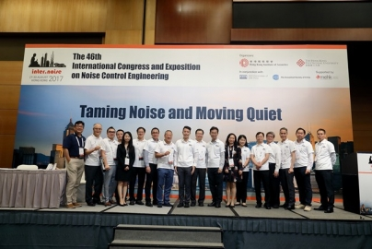
Xxxxxxxxxxxxx mxxxxxxxxxxxxxxxxxxx xxxxxxxxxxxxxxxxxxxxx xxxxxxx xxxxxxxxxxxxxxx xxxxxxxxxxxxxxxxxxxxxxxxxx xxxxxxxxxxxxxxxxxxxxxxxxxxxx xxxx xxxxxxxxxxxxxxxxxx xxxxxxxxxxxxxx xxxxxxxxxxxxxxxxxxxxxxxxx

- Excellence
Xxxxxxxxxxxxxxxxxxxxxxxxxxxxxxxxxxxxxxxxxxxxxxxxxxxxxxxxxxxxxxxxxxxxxxxxxxxxxxxxxxxxxxxxxxxxxxxxxxxxxxxxxxxxxxxxxxxxxxxxxxxxxxxxxxxxxxxxxxxxxxxxxxxxxxx

- Professional Knowhow
Xxxxxxxxxxxxxxxxxxxxxxxxxxxxxxxxxxxxxxxxxxxxxxxxxxxxxxxxxxxxxxxxxxxxxxxxxxxxxxxxxxxxxxxxxxxxxxxxxxxxxxxxxxxxxxxxxxxxxxxxxxxxxxxxxxxxxxxxxxxxxxxxxxxxxxx

- Challenges
Xxxxxxxxxxxxxxxxxxxxxxxxxxxxxxxxxxxxxxxxxxxxxxxxxxxxxxxxxxxxxxxxxxxxxxxxxxxxxxxxxxxxxxxxxxxxxxxxxxxxxxxxxxxxxxxxxxxxxxxxxxxxxxxxxxxxxxxxxxxxxxxxxxxxxxx

- Practically
Xxxxxxxxxxxxxxxxxxxxxxxxxxxxxxxxxxxxxxxxxxxxxxxxxxxxxxxxxxxxxxxxxxxxxxxxxxxxxxxxxxxxxxxxxxxxxxxxxxxxxxxxxxxxxxxxxxxxxxxxxxxxxxxxxxxxxxxxxxxxxxxxxxxxxxx

